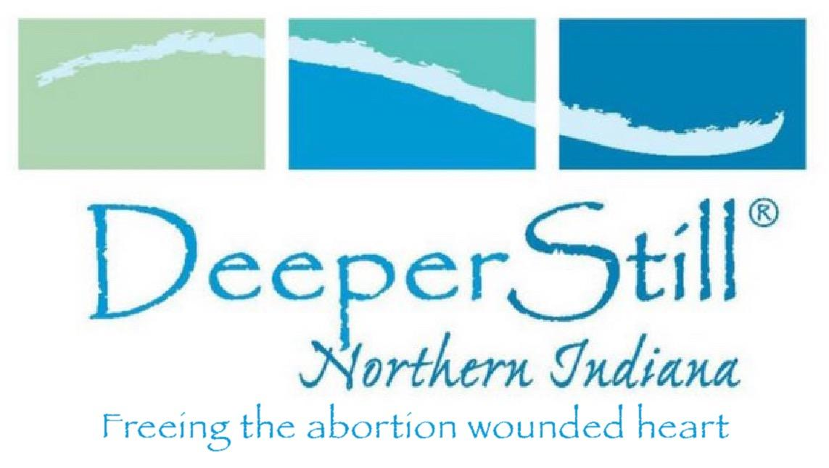 |  | Mike and Lisa Davis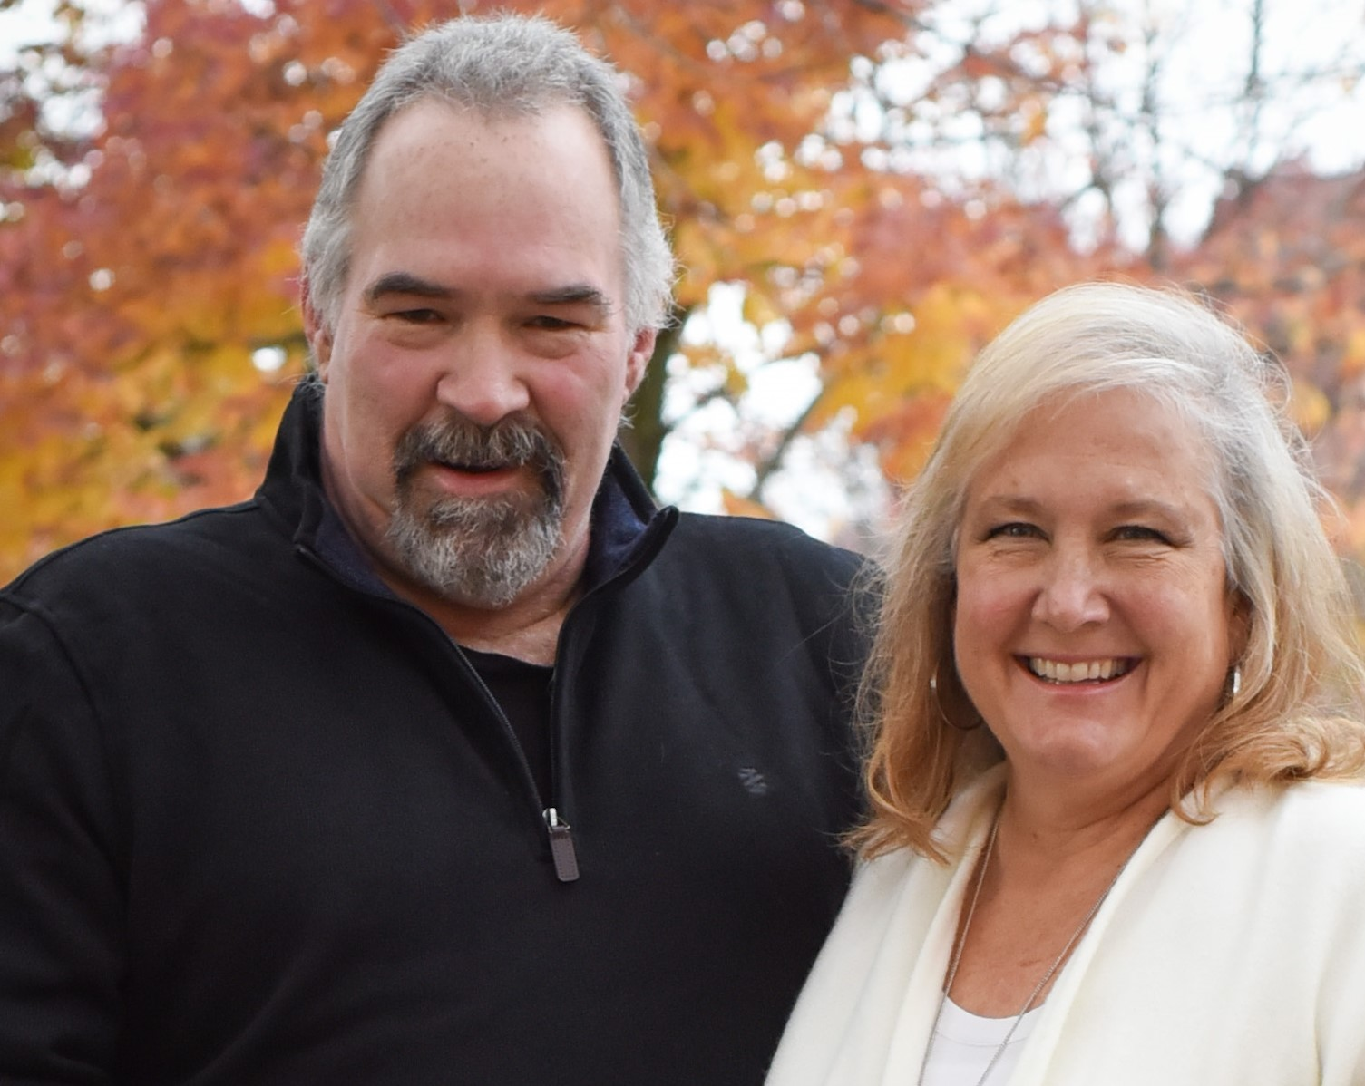
Contact  PHONE:  260-410-5109  WEBSITE:  www.deeperstillnorthernindiana.org  EMAIL:  deeperstillnorthernindiana@gmail.com |  | Lisa has over 20 years of experience working as a psychiatric nurse and another 20 years working in pregnancy resource centers helping women and their families with unplanned pregnancies. Additionally, Lisa has extensive training in dealing with the trauma of abortion, as well as personal experience with abortion and personal/spiritual healing. For nearly 20 years, Lisa facilitated Bible study/support groups addressing the specific grief and pain from a past abortion. In 2017 Lisa established Deeper Still Northern Indiana, a not-for-profit which provides Biblically based healing retreats for men and women with abortion wounded hearts, offered free of charge to participants. DSNI is a chapter of Deeper Still (national) founded by Karen Ellison in Knoxville Tennessee. Deeper Still has 27 chapters nationwide.  Lisa and her husband, Mike publicly share their abortion experience, which occurred in 1985, to help others overcome their grief and shame and to help Christians develop a helpful response to their abortion wounded family and friends. They co-facilitate Deeper Still Retreats in Indiana.  Lisa and Mike are the parents of two fine adult children and grandparents to two beautiful granddaughters. They attend Harvest Fellowship Church in Fort Wayne, IN

